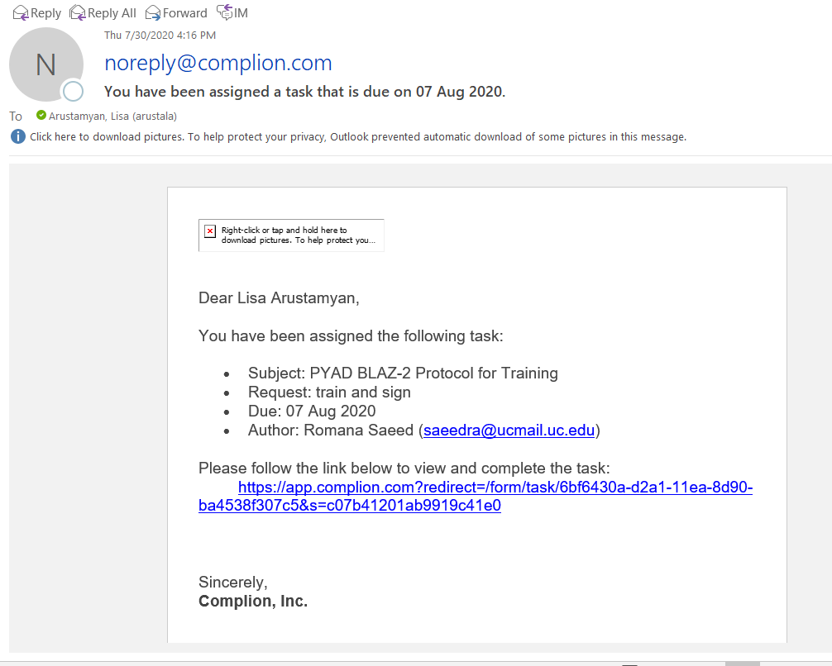
Step 1: you will receive a notification from noreply@complion.com as it is listed below. A brief description of the task assigned will be listed. Please follow the blue link to review and complete the task assigned.

PS: Unless otherwise specified by the sponsor or PI, all tasks assigned by ARS will typically be given a 7-day window to complete. Complion will automatically send reminders to your e-mail daily until the task is completed.
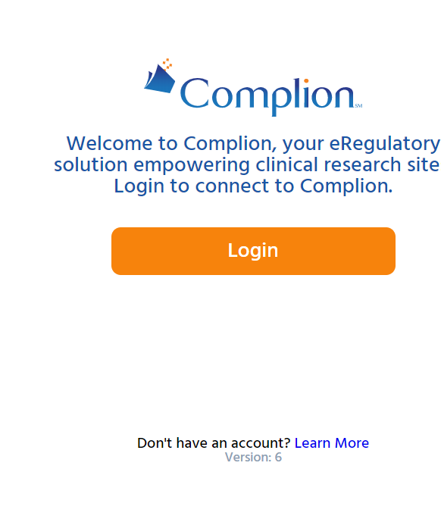
Complete all tasks within the timeline requested.
Step 1A: you will then be brought to this screen. Please follow the orange login button to proceed.

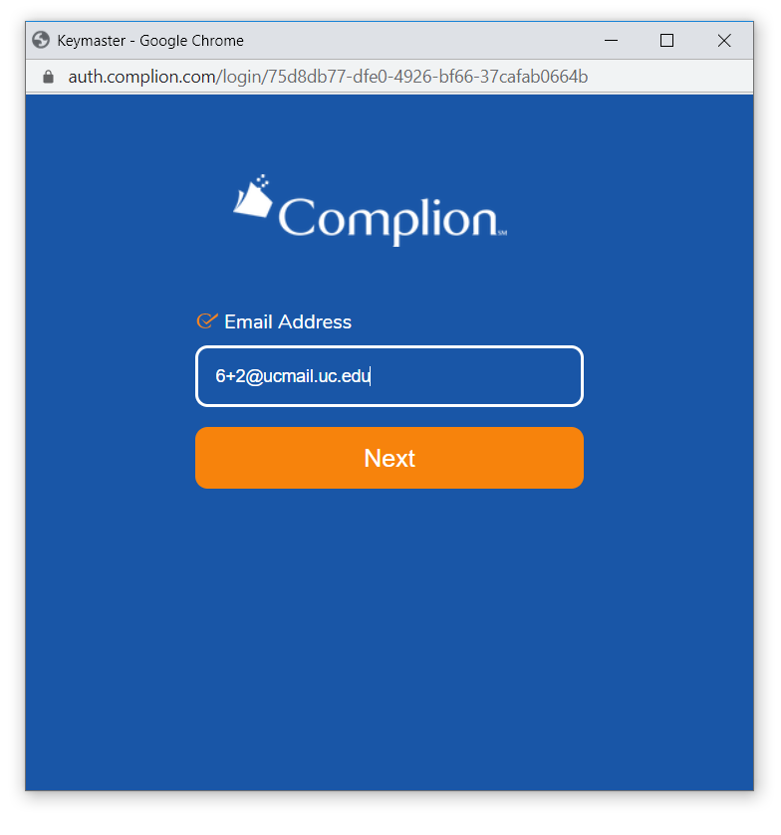
Step 1B: Your login information will typically consist of your UC 6+2 proceeded with @ucmail.uc.edu. If you are unable to login please contact the Regulatory CRP assigned to the study you are working on and they will assist you.

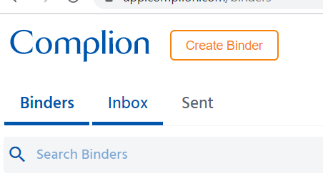

Step 2: once you are in Complion please click the ‘Inbox’ tab at the top of your browser.

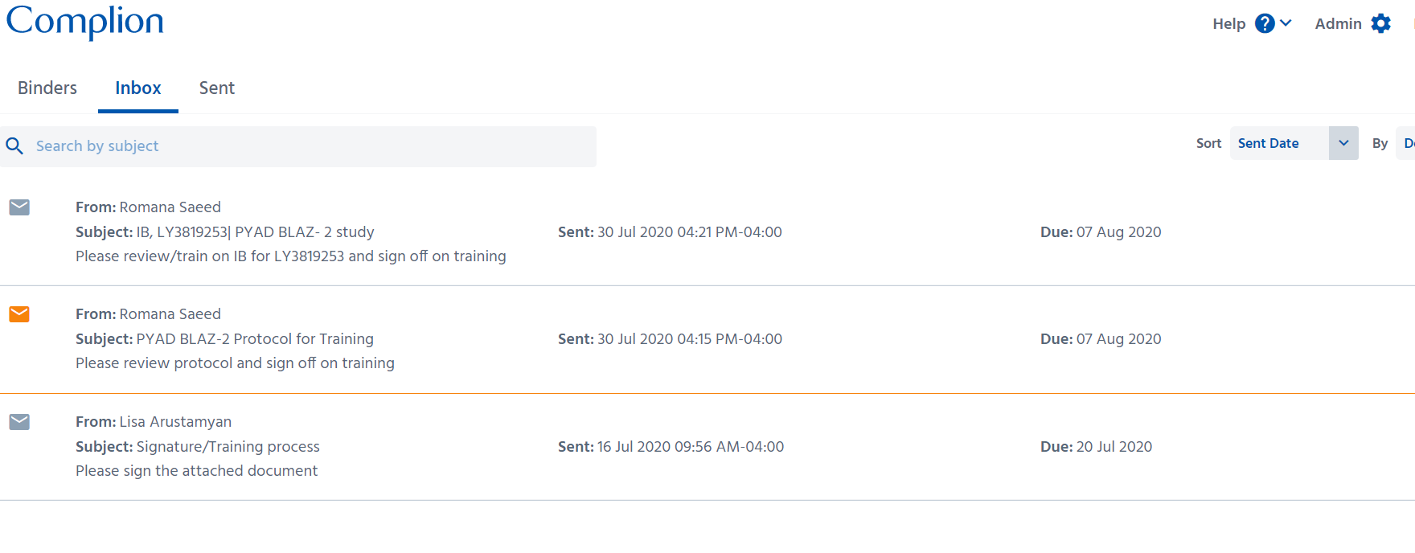
Step 3: once you are in your inbox, please proceed with reviewing your inbox messages and select the tasks you would like to complete. The task will highlight orange once selected.

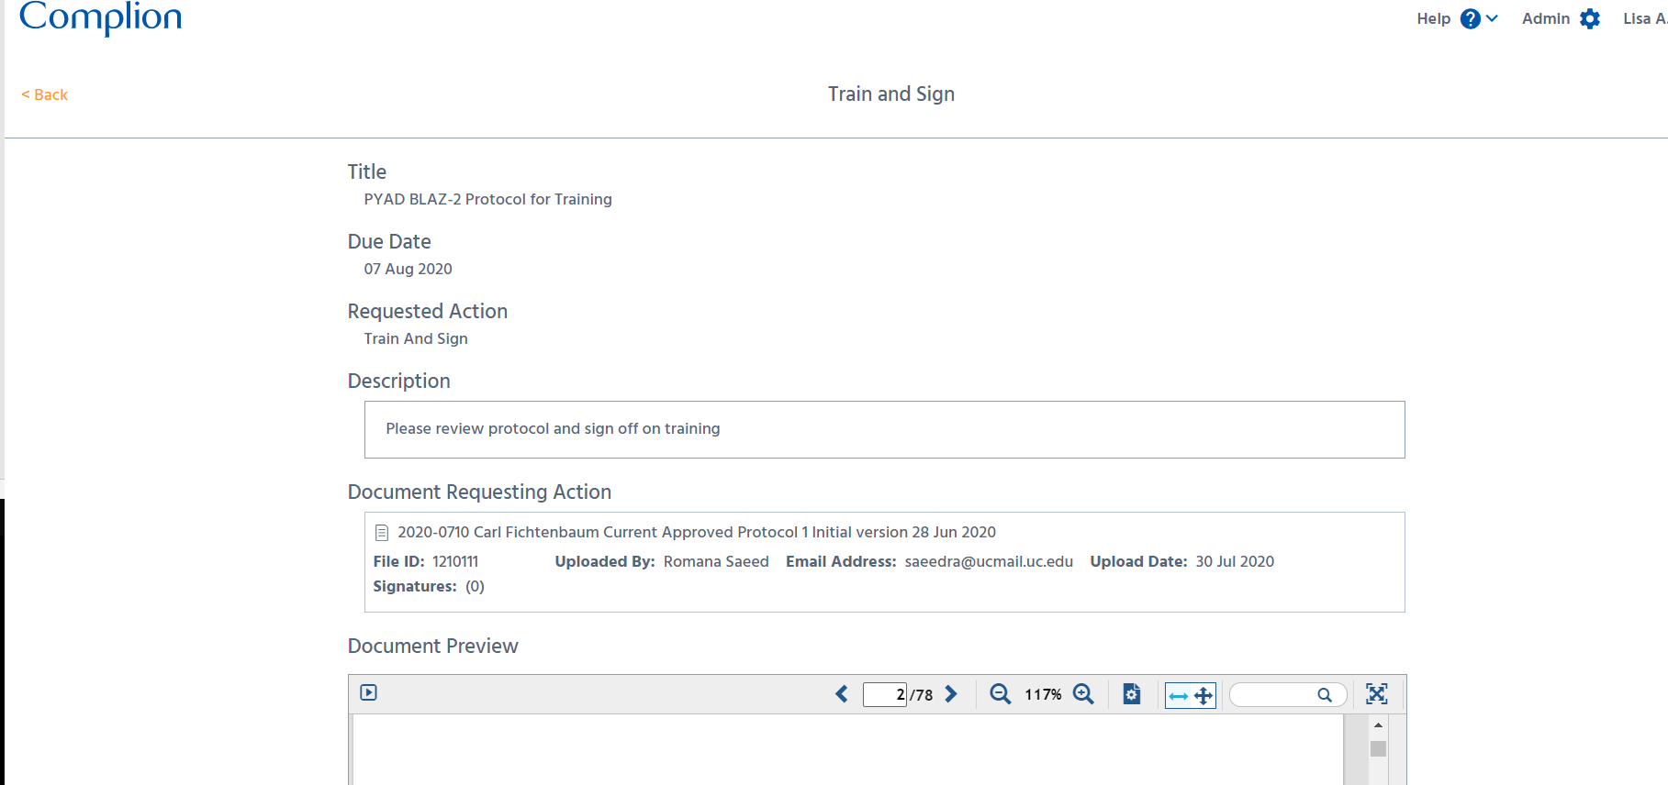
Step 4: Please select your desired task. Once done so, the following screen will appear. Typically, instructions will be listed for your convenience. Please review the description prior to completing the task. Please review the entire document before proceeding.

Step 4A: once your task is complete please scroll to the bottom of the page, and click the ‘Select Document and Sign’ button to proceed.
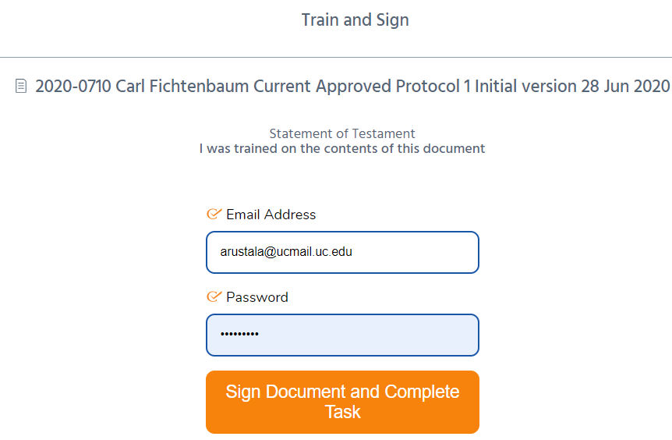

Step 4B: Authorization of Complion login information will be needed to complete the task. After your information is listed please click the orange ‘Sign Document and Complete Task’ button.

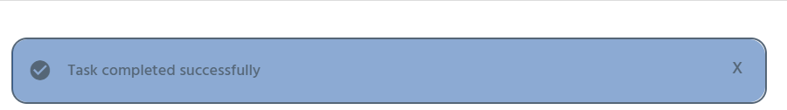

Finally: Once your task is completed you will be brought back to the document and the above blue notification will appear for a few seconds confirming the task has been completed.

The Regulatory CRP assigning this task will then be notified once the task is completed. All trainings will be collected through Complion to eliminate the need for ‘wet-ink’ and paper-training logs.
If you are having trouble signing off on the tasks assigned, please contact the assigned Regulatory CRP. They will assist you the best they can in answering any of your questions or providing guidance.

